-----

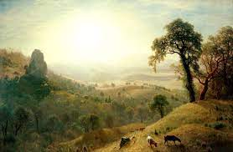

-----

This is a picture of nature and beauty untouched by humans that shows the transcendentalist art here. Transcendentalists believe that society and its rules corrupt each individual, not letting them be truly free and this painting embodies freedom. In this photo it shows animals not being affected by a certain individual corrupting their lives, but rather independent and self reliant. It shows each individual not influencing one and another but a true community.